SIMATS ENGINEERING
ASSESSMENT TOOL 3 – Assignment 2

COURSE NAME: STATISTICS WITH R PROGRAMMING COURSE CODE: ITA0407

COURSE OUTCOME COVERED

CO3: Construct and manipulate data frames using reshaping, merging, and file I/O operations in R to prepare structured datasets for analysis. (BL3, BL5)

Assessment Tool Weightage: 20%

QUESTIONS: 5 Total Marks: 100

Annexure

Assignment 2

Code of Conduct:

I _____K.Subashree_______________ (Name / Reg No) certify that this submission is my original work and that I have adhered to the guidelines specified for this assessment.
I understand that any violation of academic integrity rules will result in disciplinary action.

Signature of the student:
K.Subashree

Assignment 2:
- Generate 5 Questions for your Capstone Project module
- Apply the formulae and use the relevant graph to visualize it
- Upload the file in Github link
- Save the 5 Questions and Gihub link in the Excell sheet

QUESTIONS
1.How to visualize population growth trends across different regions using an interactive line chart in R programming?
Formula
Population Growth Rate:
$$\text{Growth Rate (\%)}=\frac{P_{t}-P_{t-1}}{P_{t-1}}×100$$
Where:
- $P_{t}$= Population in the current year.
- $P_{t-1}$= Population in the previous year.
Program Code
library(shiny)
library(plotly)
library(dplyr)

# Population Dataset
population <- data.frame(
Year = rep(2019:2024, 3),
Region = rep(c("Chennai", "Coimbatore", "Madurai"), each = 6),
Population = c(
4646732, 4750000, 4860000, 4970000, 5080000, 5180000,
1600000, 1620000, 1640000, 1660000, 1680000, 1700000,
1500000, 1520000, 1540000, 1560000, 1580000, 1600000
)
)

# User Interface
ui <- fluidPage(
titlePanel("Population Growth Analysis"),

sidebarLayout(
sidebarPanel(
selectInput(
"region",
"Select Region:",
choices = unique(population$Region),
selected = "Chennai",
multiple = TRUE
),

sliderInput(
"year",
"Select Year Range:",
min = 2019,
max = 2024,
value = c(2019, 2024),
step = 1,
sep = ""
)
),

mainPanel(
plotlyOutput("growthPlot", height = "500px")
)
)
)

# Server
server <- function(input, output) {

output$growthPlot <- renderPlotly({

data <- population %>%
filter(
Region %in% input$region,
Year >= input$year[1],
Year <= input$year[2]
)

plot_ly(
data,
x = ~Year,
y = ~Population,
color = ~Region,
type = "scatter",
mode = "lines+markers",
marker = list(size = 10),
line = list(width = 4),
text = ~paste(
"Region:", Region,
"<br>Year:", Year,
"<br>Population:", format(Population, big.mark = ",")
),
hoverinfo = "text"
) %>%
layout(
title = "Yearly Population Growth",
xaxis = list(title = "Year", dtick = 1),
yaxis = list(title = "Population"),
hovermode = "x unified",
legend = list(orientation = "h", y = -0.2)
)
})
}

shinyApp(ui, server)

OUTPUT
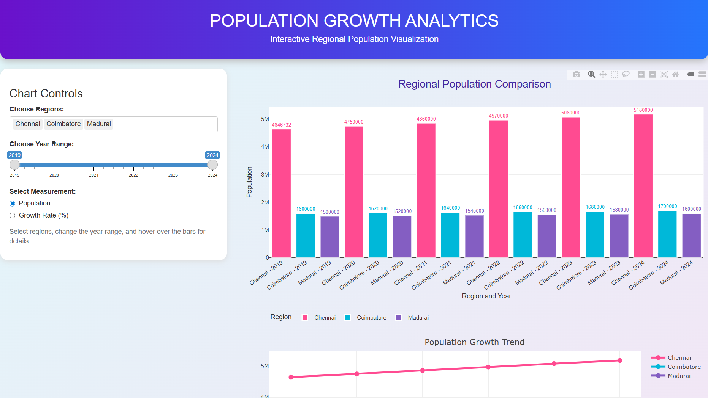

2. How to compare the population of different regions using a colourful and interactive pictorial bar chart in R programming?

Formula
Population Difference
$$D=P_{A}-P_{B}$$
Where:
- $P_{A}$= Population of Region A.
- $P_{B}$= Population of Region B.
- $D$= Difference between the populations.
Program Code
library(shiny)
library(plotly)
library(dplyr)
library(fontawesome)

# Population Dataset
population <- data.frame(
Region = c(
"Chennai", "Coimbatore",
"Madurai", "Trichy", "Salem"
),
Men = c(2700000, 880000, 820000, 550000, 490000),
Women = c(2580000, 840000, 800000, 530000, 460000)
)

population$Total <- population$Men + population$Women

# User Interface
ui <- fluidPage(

tags$head(
tags$style(HTML("
body {
background: linear-gradient(135deg, #E3F2FD, #FCE4EC);
font-family: Arial;
}

.header {
background: linear-gradient(90deg, #7B2FF7, #F107A3);
color: white;
text-align: center;
padding: 25px;
border-radius: 18px;
margin-bottom: 20px;
}

.well {
background: white;
border-radius: 15px;
border: none;
}

.info-card {
background: white;
border-radius: 15px;
padding: 18px;
margin-bottom: 15px;
text-align: center;
box-shadow: 0 4px 12px #dddddd;
}
"))
),

div(
class = "header",
h1("👨‍👩‍👧 POPULATION EXPLORER"),
h4("Interactive Regional Population Comparison"),
p("Explore population, men, and women across regions")
),

sidebarLayout(

sidebarPanel(
h3("Chart Controls"),

selectInput(
"regions",
"Select Regions:",
choices = population$Region,
selected = population$Region,
multiple = TRUE
),

radioButtons(
"chart_type",
"Select Chart:",
choices = c(
"Men vs Women" = "gender",
"Total Population" = "total"
),
selected = "gender"
),

checkboxInput(
"show_labels",
"Show Population Labels",
TRUE
)
),

mainPanel(

fluidRow(
column(
4,
div(
class = "info-card",
h4("👥 Regions"),
h2(textOutput("region_count"))
)
),

column(
4,
div(
class = "info-card",
h4("👨 Men"),
h2(textOutput("men_total"))
)
),

column(
4,
div(
class = "info-card",
h4("👩 Women"),
h2(textOutput("women_total"))
)
)
),

plotlyOutput("population_chart", height = "500px"),

br(),

plotlyOutput("share_chart", height = "400px")
)
)
)

# Server
server <- function(input, output) {

selected_data <- reactive({
population %>%
filter(Region %in% input$regions)
})

output$region_count <- renderText({
nrow(selected_data())
})

output$men_total <- renderText({
format(sum(selected_data()$Men), big.mark = ",")
})

output$women_total <- renderText({
format(sum(selected_data()$Women), big.mark = ",")
})

# Main Interactive Bar Chart
output$population_chart <- renderPlotly({

data <- selected_data()

req(nrow(data) > 0)

if (input$chart_type == "gender") {

plot_data <- data.frame(
Region = rep(data$Region, 2),
Gender = c(
rep("Men", nrow(data)),
rep("Women", nrow(data))
),
Population = c(data$Men, data$Women)
)

plot_data$Icon <- ifelse(
plot_data$Gender == "Men",
"\u2642",
"\u2640"
)

plot_data$Label <- if (input$show_labels) {
paste0(
plot_data$Icon, " ",
format(plot_data$Population, big.mark = ",")
)
} else {
""
}

p <- plot_ly(
plot_data,
x = ~Region,
y = ~Population,
color = ~Gender,
colors = c("#4285F4", "#FF4F9A"),
type = "bar",
text = ~Label,
textposition = "outside",
hovertemplate = paste(
"<b>%{x}</b>",
"<br>Group: %{fullData.name}",
"<br>Population: %{y:,}",
"<extra></extra>"
)
) %>%
layout(
barmode = "group",
legend = list(orientation = "h", y = 1.12)
)

} else {

data$Label <- if (input$show_labels) {
format(data$Total, big.mark = ",")
} else {
""
}

p <- plot_ly(
data,
x = ~Region,
y = ~Total,
type = "bar",
color = ~Region,
colors = c(
"#7B2FF7", "#F107A3", "#00B4D8",
"#00C853", "#FF9800"
),
text = ~Label,
textposition = "outside",
hovertemplate = paste(
"<b>%{x}</b>",
"<br>Total Population: %{y:,}",
"<extra></extra>"
)
) %>%
layout(showlegend = FALSE)
}

p %>%
layout(
title = list(
text = "👨 Men vs 👩 Women Population",
font = list(size = 22, color = "#7B2FF7")
),
xaxis = list(title = "Region"),
yaxis = list(
title = "Population",
rangemode = "tozero"
),
plot_bgcolor = "white",
paper_bgcolor = "rgba(255,255,255,0)",
margin = list(t = 100, b = 70)
) %>%
config(
displaylogo = FALSE,
displayModeBar = TRUE
)
})

# Population Share Pie Chart
output$share_chart <- renderPlotly({

data <- selected_data()

req(nrow(data) > 0)

plot_ly(
data,
labels = ~Region,
values = ~Total,
type = "pie",
hole = 0.45,
textinfo = "label+percent",
marker = list(
colors = c(
"#7B2FF7", "#F107A3", "#00B4D8",
"#00C853", "#FF9800"
)
),
hovertemplate = paste(
"<b>%{label}</b>",
"<br>Population: %{value:,}",
"<br>Share: %{percent}",
"<extra></extra>"
)
) %>%
layout(
title = "🌈 Population Share by Region",
showlegend = TRUE,
paper_bgcolor = "rgba(255,255,255,0)"
)
})
}

shinyApp(ui = ui, server = server)

OUTPUT
3. How to analyze the relationship between population, geographical area, and population density using an interactive bubble chart in R programming?
Formula
Population Density:
$$\text{Population Density}=\frac{\text{Population}}{{\text{Area in km}}^{2}}$$
The result represents the number of people per square kilometre.
Example:
If a region has a population of 5,000,000 and an area of 500 km²:
Program Code
library(shiny)
library(plotly)

# -------------------- POPULATION DATA --------------------

population_data <- data.frame(
Year = c(2020, 2021, 2022, 2023, 2024, 2025),
Region = rep(
c("Chennai", "Coimbatore", "Madurai", "Trichy", "Salem"),
each = 6
),
Population = c(
5000000, 5050000, 5100000, 5150000, 5200000, 5250000,
1700000, 1720000, 1740000, 1760000, 1780000, 1800000,
1550000, 1570000, 1590000, 1610000, 1630000, 1650000,
1050000, 1065000, 1080000, 1095000, 1110000, 1125000,
900000, 915000, 930000, 945000, 960000, 975000
)
)

# Illustrative male and female population proportions
population_data$Male <- round(population_data$Population * 0.505)
population_data$Female <- population_data$Population -
population_data$Male

regions <- unique(population_data$Region)

# -------------------- USER INTERFACE --------------------

ui <- fluidPage(

tags$head(
tags$style(HTML("
body {
background: linear-gradient(135deg, #e0f7fa, #f3e5f5);
font-family: Arial, sans-serif;
}

.main-title {
background: linear-gradient(90deg, #4527a0, #00838f);
color: white;
padding: 25px;
text-align: center;
border-radius: 15px;
margin-bottom: 20px;
}

.info-card {
background: white;
padding: 20px;
border-radius: 15px;
text-align: center;
margin-bottom: 20px;
box-shadow: 0 4px 12px rgba(0,0,0,0.12);
}

.info-card h4 {
color: #555;
}

.info-card h2 {
color: #4527a0;
font-weight: bold;
}

.chart-card {
background: white;
padding: 15px;
border-radius: 15px;
margin-bottom: 20px;
box-shadow: 0 4px 12px rgba(0,0,0,0.10);
}

.sidebar {
background: white;
padding: 20px;
border-radius: 15px;
margin-bottom: 20px;
}

.footer {
text-align: center;
padding: 15px;
color: #555;
}
"))
),

# Dashboard heading
div(
class = "main-title",
h1("🌍 Population Growth Analysis"),
h4("Interactive Population Visualization and Prediction"),
p("Explore population trends across major cities of Tamil Nadu")
),

sidebarLayout(

# -------------------- SIDEBAR --------------------

sidebarPanel(
class = "sidebar",

h3("Dashboard Controls"),

selectInput(
inputId = "region",
label = "Select Region:",
choices = c("All Regions", regions),
selected = "All Regions"
),

sliderInput(
inputId = "year",
label = "Select Year Range:",
min = 2020,
max = 2025,
value = c(2020, 2025),
step = 1,
sep = ""
),

hr(),

h4("About This Project"),
p("This dashboard explores population trends using interactive charts."),
p("Select a region and year range to explore the data."),

tags$small(
"Note: The included population figures are illustrative sample data, not official census statistics."
)
),

# -------------------- MAIN DASHBOARD --------------------

mainPanel(

# Summary cards
fluidRow(

column(
width = 4,
div(
class = "info-card",
h4("👥 Total Population"),
h2(textOutput("total_population"))
)
),

column(
width = 4,
div(
class = "info-card",
h4("👨 Male Population"),
h2(textOutput("male_population"))
)
),

column(
width = 4,
div(
class = "info-card",
h4("👩 Female Population"),
h2(textOutput("female_population"))
)
)
),

# First row of charts
fluidRow(

column(
width = 6,
div(
class = "chart-card",
h3("📈 Population Growth Trend"),
plotlyOutput("growth_plot", height = "350px")
)
),

column(
width = 6,
div(
class = "chart-card",
h3("🍩 Male vs Female Population"),
plotlyOutput("gender_plot", height = "350px")
)
)
),

# Second row of charts
fluidRow(

column(
width = 6,
div(
class = "chart-card",
h3("🫧 Population Bubble Chart"),
plotlyOutput("bubble_plot", height = "350px")
)
),

column(
width = 6,
div(
class = "chart-card",
h3("📊 Regional Population Comparison"),
plotlyOutput("comparison_plot", height = "350px")
)
)
),

# Data table
fluidRow(
column(
width = 12,
div(
class = "chart-card",
h3("📋 Population Data Table"),
tableOutput("data_table")
)
)
)
)
),

div(
class = "footer",
p("Population Growth Analysis and Future Prediction | R Programming")
)
)

# -------------------- SERVER --------------------

server <- function(input, output, session) {

# Filter data based on user selections
filtered_data <- reactive({

data <- population_data

if (input$region != "All Regions") {
data <- data[data$Region == input$region, ]
}

data <- data[
data$Year >= input$year[1] &
data$Year <= input$year[2],
]

data
})

# -------------------- SUMMARY CARDS --------------------

output$total_population <- renderText({
format(
sum(filtered_data()$Population),
big.mark = ",",
scientific = FALSE
)
})

output$male_population <- renderText({
format(
sum(filtered_data()$Male),
big.mark = ",",
scientific = FALSE
)
})

output$female_population <- renderText({
format(
sum(filtered_data()$Female),
big.mark = ",",
scientific = FALSE
)
})

# -------------------- 1. GROWTH TREND --------------------

output$growth_plot <- renderPlotly({

data <- filtered_data()

plot <- plotly::plot_ly(
data,
x = ~Year,
y = ~Population,
color = ~Region,
type = "scatter",
mode = "lines+markers",
marker = list(size = 9),
line = list(width = 3),
text = ~paste(
"Region:", Region,
"<br>Year:", Year,
"<br>Population:", format(Population, big.mark = ",")
),
hoverinfo = "text"
)

plotly::layout(
plot,
title = "Population Growth Over Time",
xaxis = list(title = "Year", dtick = 1),
yaxis = list(title = "Population"),
legend = list(
orientation = "h",
x = 0.5,
xanchor = "center",
y = -0.25
),
margin = list(b = 80)
)
})

# -------------------- 2. GENDER DONUT CHART --------------------

output$gender_plot <- renderPlotly({

data <- filtered_data()

gender_data <- data.frame(
Gender = c("Male 👨", "Female 👩"),
Population = c(
sum(data$Male),
sum(data$Female)
)
)

plot <- plotly::plot_ly(
data = gender_data,
labels = ~Gender,
values = ~Population,
type = "pie",
hole = 0.60,
textinfo = "label+percent",
hovertemplate = paste(
"%{label}",
"<br>Population: %{value:,}",
"<br>Percentage: %{percent}",
"<extra></extra>"
),
marker = list(
colors = c("#5C6BC0", "#EC407A")
)
)

plotly::layout(
plot,
title = "Population Distribution by Gender",
showlegend = TRUE,
legend = list(
orientation = "h",
x = 0.5,
xanchor = "center",
y = -0.15
),
margin = list(b = 60)
)
})

# -------------------- 3. BUBBLE CHART --------------------

output$bubble_plot <- renderPlotly({

data <- filtered_data()

plot <- plotly::plot_ly(
data,
x = ~Year,
y = ~Population,
size = ~Population,
color = ~Region,
type = "scatter",
mode = "markers",
sizes = c(15, 60),
marker = list(
opacity = 0.75,
line = list(width = 1, color = "white")
),
text = ~paste(
"Region:", Region,
"<br>Year:", Year,
"<br>Population:", format(Population, big.mark = ",")
),
hoverinfo = "text"
)

plotly::layout(
plot,
title = "Population Distribution Bubble Chart",
xaxis = list(title = "Year", dtick = 1),
yaxis = list(title = "Population"),
legend = list(
orientation = "h",
x = 0.5,
xanchor = "center",
y = -0.25
),
margin = list(b = 80)
)
})

# -------------------- 4. REGIONAL COMPARISON --------------------

output$comparison_plot <- renderPlotly({

data <- filtered_data()

comparison_data <- aggregate(
Population ~ Region,
data = data,
FUN = mean
)

plot <- plotly::plot_ly(
comparison_data,
x = ~Region,
y = ~Population,
type = "bar",
marker = list(
color = c(
"#7E57C2",
"#26A69A",
"#EC407A",
"#FFA726",
"#42A5F5"
)
),
text = ~format(round(Population), big.mark = ","),
textposition = "auto",
hovertemplate = paste(
"Region: %{x}",
"<br>Average Population: %{y:,.0f}",
"<extra></extra>"
)
)

plotly::layout(
plot,
title = "Average Population by Region",
xaxis = list(title = "Region"),
yaxis = list(title = "Average Population"),
showlegend = FALSE
)
})

# -------------------- 5. DATA TABLE --------------------

output$data_table <- renderTable({

data <- filtered_data()

data <- data[
order(data$Region, data$Year),
c("Year", "Region", "Population", "Male", "Female")
]

names(data) <- c(
"Year",
"Region",
"Total Population",
"Male Population",
"Female Population"
)

data$`Total Population` <- format(
data$`Total Population`,
big.mark = ",",
scientific = FALSE
)

data$`Male Population` <- format(
data$`Male Population`,
big.mark = ",",
scientific = FALSE
)

data$`Female Population` <- format(
data$`Female Population`,
big.mark = ",",
scientific = FALSE
)

data
})

}

# -------------------- RUN APPLICATION --------------------

shinyApp(
ui = ui,
server = server
)

OUTPUT
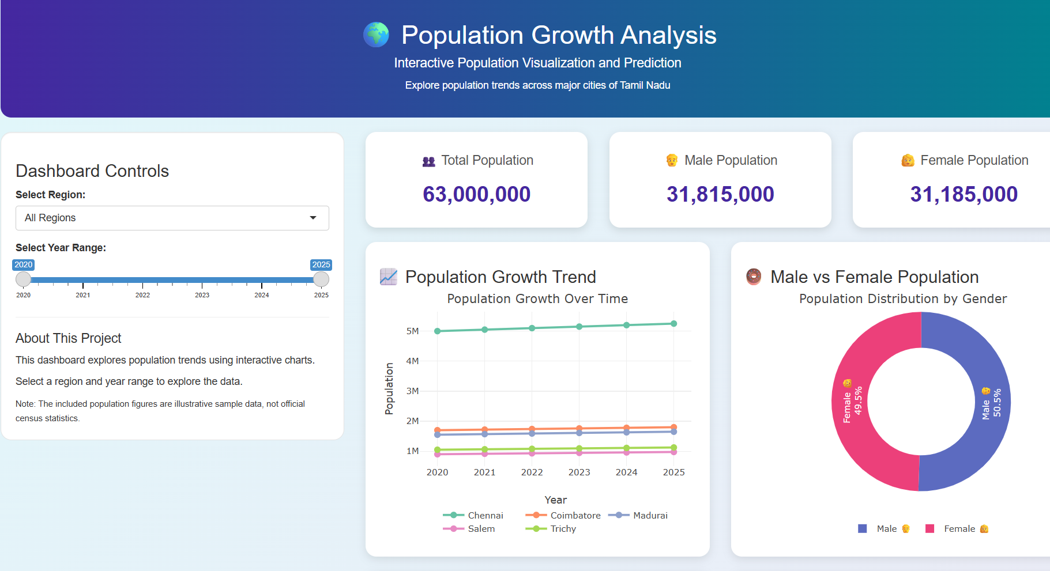
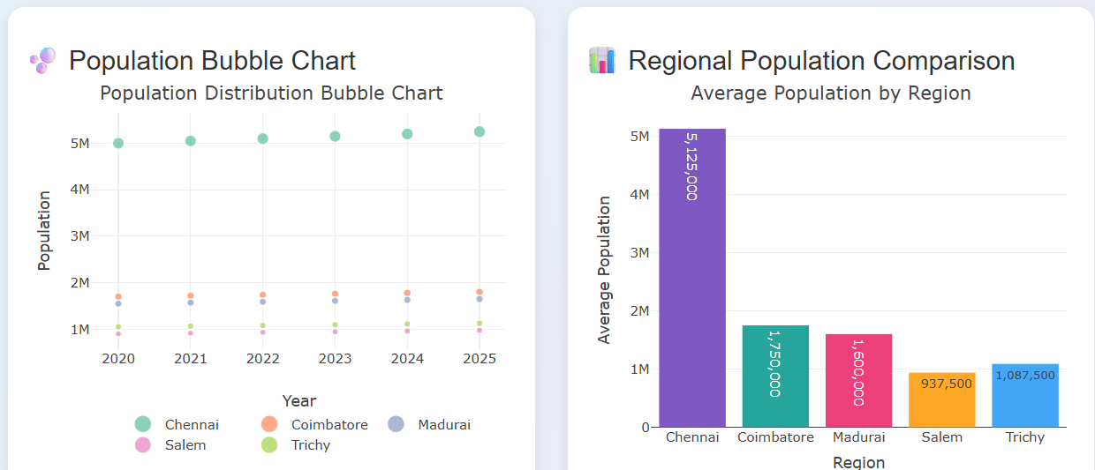
3. How to analyze the relationship between population, geographical area, and population density using an interactive bubble chart in R programming?
Formula
Population Density:
$$\text{Population Density}=\frac{\text{Population}}{{\text{Area (km}}^{2}\text{)}}$$

Where:
- Population: Total number of people in a region.
- Area: Geographical area measured in square kilometres.
- Population Density: Number of people per square kilometre.
Program Code
# Question 3: Interactive Population Bubble Chart

# Install plotly if it is not already installed
if (!requireNamespace("plotly", quietly = TRUE)) {
install.packages("plotly", repos = "https://cloud.r-project.org")
}

library(plotly)

# Create population dataset
population_data <- data.frame(
Region = c("Chennai", "Coimbatore", "Madurai", "Trichy", "Salem"),
Population = c(5200000, 1800000, 1650000, 1125000, 975000),
Area = c(426, 642, 147, 167, 124)
)

# Calculate population density
population_data$Density <-
population_data$Population / population_data$Area

# Display population data
print(population_data)

# Create interactive bubble chart
plot_ly(
data = population_data,
x = ~Area,
y = ~Population,
size = ~Density,
color = ~Region,
type = "scatter",
mode = "markers",
sizes = c(15, 60),
marker = list(
opacity = 0.8,
line = list(width = 1, color = "white")
),
text = ~paste(
"Region:", Region,
"<br>Population:", format(Population, big.mark = ","),
"<br>Area:", Area, "km²",
"<br>Density:", round(Density, 2), "people/km²"
),
hoverinfo = "text"
) %>%
layout(
title = "Population, Area and Density",
xaxis = list(title = "Geographical Area (km²)"),
yaxis = list(title = "Population"),
legend = list(
orientation = "h",
x = 0.5,
xanchor = "center",
y = -0.2
)
)
OUTPUT
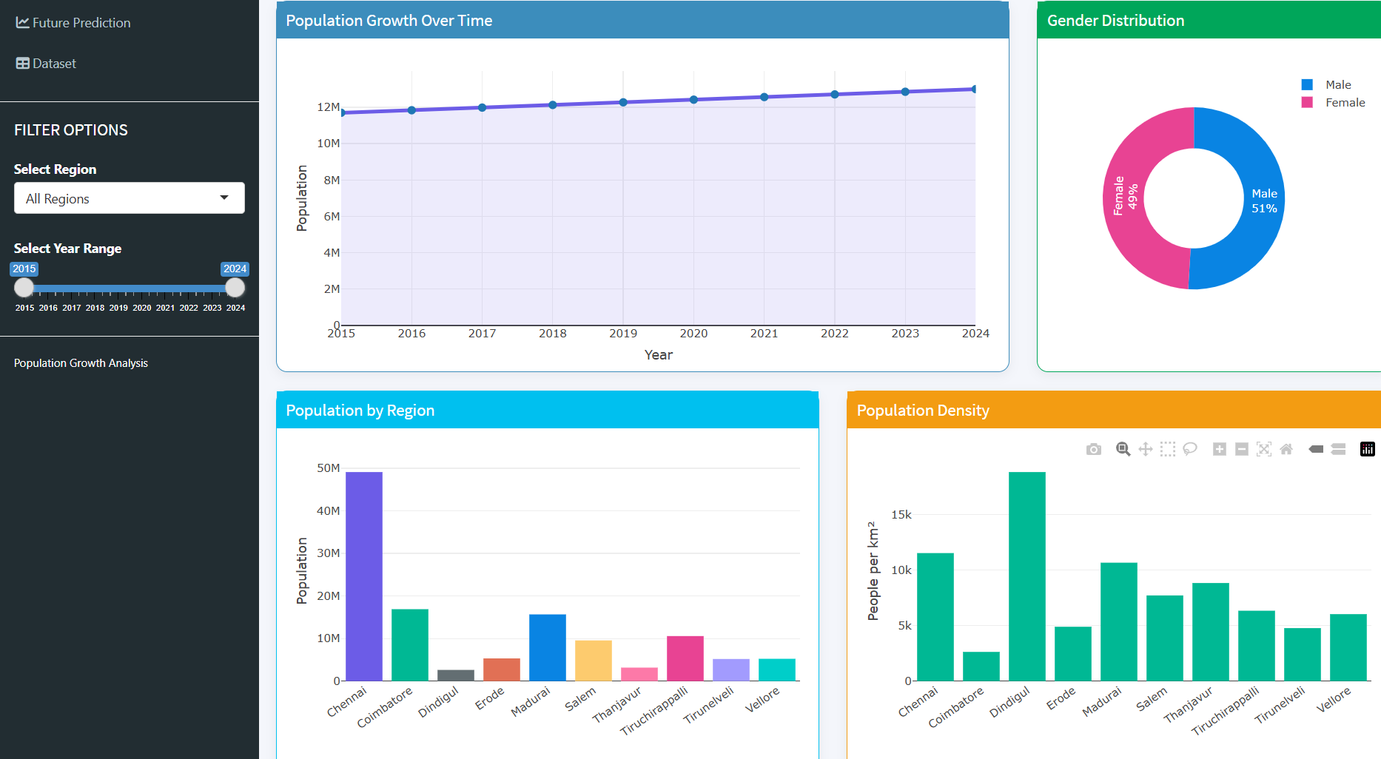
4. How to visualize population distribution and growth patterns across different regions and years using an interactive heatmap in R programming?
Formula
Population growth rate:
$$\text{Growth Rate (\%)}=\frac{\text{Current Population}-\text{Previous Population}}{\text{Previous Population}}×100$$
Population density:
$$\text{Population Density}=\frac{\text{Population}}{\text{Area}}$$
Program Code
Interactive Heatmap for Population Distribution and Growth
if (!requireNamespace("plotly", quietly = TRUE)) {
install.packages("plotly")
}
library(plotly)
Step 1: Create population data
years <- 2019:2024
regions <- c("Chennai", "Coimbatore", "Madurai", "Trichy", "Salem")
population_matrix <- matrix(
c(
4646732, 4700000, 4750000, 4800000, 4850000, 4900000,
1600000, 1620000, 1640000, 1660000, 1680000, 1700000,
1500000, 1520000, 1540000, 1560000, 1580000, 1600000,
1000000, 1020000, 1040000, 1060000, 1080000, 1100000,
900000, 920000, 940000, 960000, 980000, 1000000
),
nrow = 5,
byrow = TRUE,
dimnames = list(regions, years)
)
Step 2: Calculate growth rates
growth_matrix <- matrix(
NA_real_,
nrow = nrow(population_matrix),
ncol = ncol(population_matrix),
dimnames = dimnames(population_matrix)
)
growth_matrix[, 2:6] <-
(population_matrix[, 2:6] - population_matrix[, 1:5]) /
population_matrix[, 1:5] * 100
Step 3: Display population heatmap
population_plot <- plot_ly(
x = years,
y = regions,
z = population_matrix,
type = "heatmap",
colorscale = "YlOrRd",
hovertemplate = paste(
"Region: %{y}",
"Year: %{x}",
"Population: %{z:,.0f}"
)
) %>%
layout(
title = "Population Distribution Heatmap",
xaxis = list(title = "Year"),
yaxis = list(title = "Region")
)
print(population_plot)
Step 4: Display growth rate heatmap
growth_plot <- plot_ly(
x = years,
y = regions,
z = growth_matrix,
type = "heatmap",
colorscale = "Viridis",
hovertemplate = paste(
"Region: %{y}",
"Year: %{x}",
"Growth Rate: %{z:.2f}%"
)
) %>%
layout(
title = "Population Growth Rate Heatmap",
xaxis = list(title = "Year"),
yaxis = list(title = "Region")
)
print(growth_plot)
Step 5: Display results
cat("Population Growth Rates (%):\n")
print(round(growth_matrix, 2))
OUTPUT
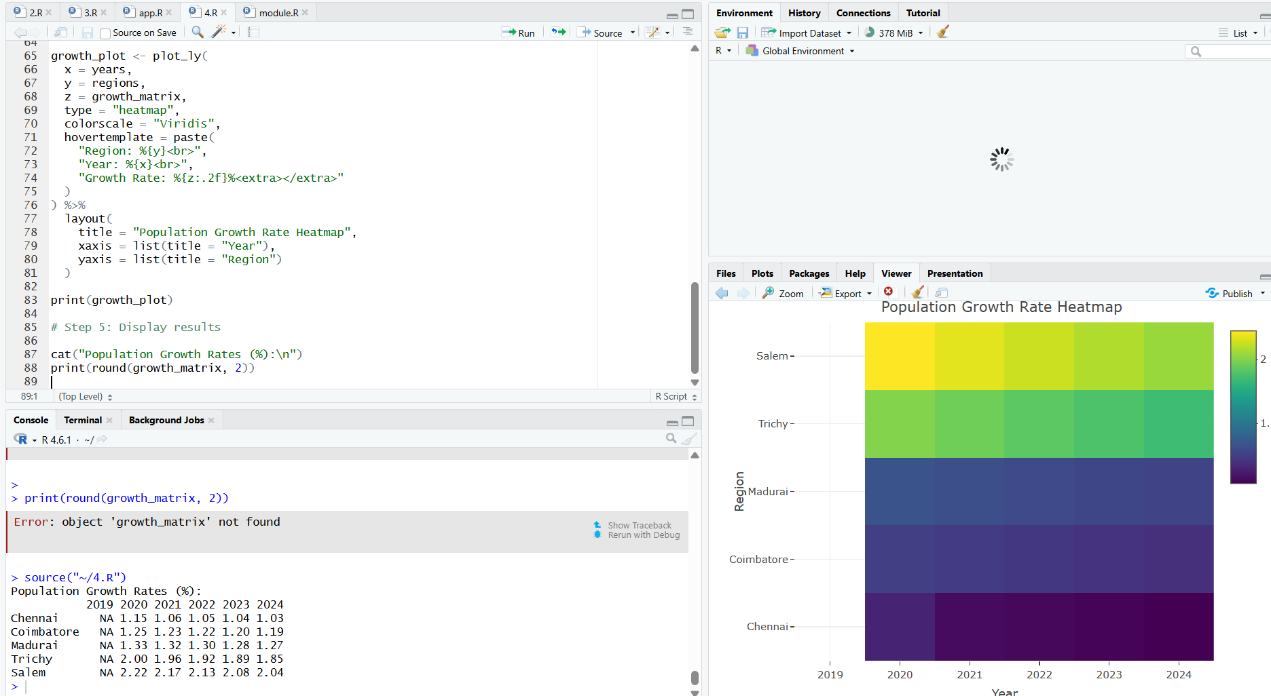
5. How to develop an interactive population visualization dashboard using R Shiny with multiple charts, summary cards, and dynamic filters?
Formula
1. Total Population
Total Population = Σ Population
2. Average Population
Average Population = Total Population / Number of Observations
3. Population Growth
Population Growth = Current Population − Previous Population
4. Population Growth Rate
Population Growth Rate (%) = ((Current Population − Previous Population) / Previous Population) × 100
5. Number of Regions
Number of Regions = Count of Unique Regions
Program Code
library(shiny)
library(ggplot2)
library(plotly)
population_data <- data.frame(
Year = rep(2019:2024, times = 5),
Region = rep(c("Chennai", "Coimbatore", "Madurai", "Trichy", "Salem"), each = 6),
Population = c(
4646732, 4700000, 4750000, 4800000, 4850000, 4900000,
1600000, 1620000, 1640000, 1660000, 1680000, 1700000,
1500000, 1520000, 1540000, 1560000, 1580000, 1600000,
1000000, 1020000, 1040000, 1060000, 1080000, 1100000,
900000, 920000, 940000, 960000, 980000, 1000000
)
)
ui <- fluidPage(
titlePanel("Population Growth Analysis Dashboard"),
sidebarLayout(
sidebarPanel(
selectInput(
"region",
"Select Region",
choices = c("All Regions", unique(population_data$Region))
),
sliderInput(
"year",
"Select Year Range",
min = 2019,
max = 2024,
value = c(2019, 2024),
step = 1
)
),
mainPanel(
h3("Total Population"),
textOutput("total_population"),

h3("Average Population"),
textOutput("average_population"),

h3("Number of Regions"),
textOutput("region_count"),

h3("Population Growth Trend"),
plotlyOutput("line_chart"),

h3("Population Comparison"),
plotlyOutput("bar_chart"),

h3("Population Distribution"),
plotlyOutput("pie_chart"),

h3("Population Data Table"),
tableOutput("data_table")
)
)
)
server <- function(input, output, session) {
filtered_data <- reactive({
data <- population_data[
population_data$Year >= input$year[1] &
population_data$Year <= input$year[2],
]
if (input$region != "All Regions") {
data <- data[data$Region == input$region, ]
}

data
})
output$total_population <- renderText({
format(sum(filtered_data()$Population), big.mark = ",")
})
output$average_population <- renderText({
format(round(mean(filtered_data()$Population)), big.mark = ",")
})
output$region_count <- renderText({
length(unique(filtered_data()$Region))
})
output$line_chart <- renderPlotly({
p <- ggplot(
filtered_data(),
aes(x = Year, y = Population, color = Region, group = Region)
) +
geom_line(linewidth = 1.2) +
geom_point(size = 3) +
labs(
title = "Population Growth Over Time",
x = "Year",
y = "Population"
) +
theme_minimal()
ggplotly(p)
})
output$bar_chart <- renderPlotly({
p <- ggplot(
filtered_data(),
aes(x = Region, y = Population, fill = Region)
) +
geom_col() +
labs(
title = "Population Comparison",
x = "Region",
y = "Population"
) +
theme_minimal()
ggplotly(p)
})
output$pie_chart <- renderPlotly({
data <- aggregate(
Population ~ Region,
data = filtered_data(),
FUN = sum
)
plot_ly(
data,
labels = ~Region,
values = ~Population,
type = "pie",
textinfo = "label+percent"
)
})
output$data_table <- renderTable({
filtered_data()
})
}
shinyApp(ui = ui, server = server)
OUTPUT

